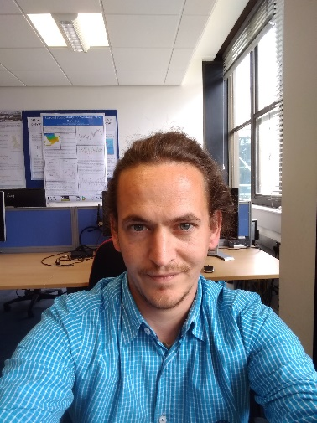 | Barnaby Andrews  I am an interdisciplinary environmental scientist with advanced technical skills in GIS, data analysis and scripting. I also have extensive knowledge and experience in environmental economics and in particular the valuation of non-market goods using stated preference techniques. My experience is broad ranging and includes GIS consulting (with particular experience in analysing GPS tracking data), valuing the well-being benefits of contact with nature and accounting for uncertainty in the valuation and mitigation of natural hazards.  RELEVANT EXPERIENCE  - Designing a choice experiment to examine the impact of changes in management measures on the benefits of recreational sea angling experiences.  Environmental Impact Assessment: Examining the impacts of continued mining and trans-shipping activities on artisanal fishers in Liberia through a 3 year GPS tracking program.  RELEVANT PUBLICATIONS  Andrews, Barnaby & Ferrini, Silvia & Bateman, Ian. (2017). Good parks – bad parks: the influence of perceptions of location on WTP and preference motives for urban parks. Journal of Environmental Economics and Policy. 1-21. 10.1080/21606544.2016.1268543.  Perino, Grischa & Andrews, Barnaby & Kontoleon, Andreas & Bateman, Ian. (2014). The Value of Urban Green Space in Britain: A Methodological Framework for Spatially Referenced Benefit Transfer. Environmental and Resource Economics. 57. 10.1007/s10640-013-9665-8.  Bateman, Ian & Harwood, Amii & M. Mace, Georgina & T. Watson, Robert & Abson, David & Andrews, Barnaby & Binner, Amy & Crowe, Andrew & H. Day, Brett & Dugdale, Steve & Fezzi, Carlo & Foden, Jo & Hadley, David & Haines-Young, Roy & Hulme, Mark & Kontoleon, Andreas & Lovett, Andrew & Munday, Paul & Pascual, Unai & Termansen, M. (2013). Ecosystem Services: Nature's Balance Sheet Response. Science. 342. 421-422.  Bateman, Ian & Harwood, Amii & M Mace, Georgina & T Watson, Robert & Abson, David & Andrews, Barnaby & Binner, Amy & Crowe, Andrew & H Day, Brett & Dugdale, Steve & Fezzi, Carlo & Foden, Jo & Hadley, David & Haines-Young, Roy & Hulme, Mark & Kontoleon, Andreas & Lovett, Andrew & Munday, Paul & Pascual, Unai & Termansen, M. (2013). Bringing Ecosystem Services into Economic Decision-Making: Land Use in the United Kingdom. Science (New York, N.Y.). 341. 45-50. 10.1126/science.1234379.  I.J. Bateman, A. Harwood, D.J. Abson, B. Andrews, A. Crowe, S. Dugdale, C. Fezzi, J. Foden*, R. Haines-Young, M. Hulme, P. Munday, U. Pascual, J. Paterson, G. Perino, A. Sen, G. Siriwardena and M. Termansen (2014) Economic Analysis for the UK National Ecosystem Assessment: Synthesis and Scenario Valuation of Changes in Ecosystem Services. Environmental and Resource Economics (2014) 57:273-297
POSISTION

Specialist Environmental Economist

QUALIFICATIONS

PhD - Environmental Science (Specialising in Environmental Economics)

MRes - Research Masters in Enviornmental Social Science (Distinction)

Bsc Environmental Science (1:1)

AREAS OF EXPERTISE

- Valuation of ecosystem services
- Stated preference valuation methods
- Value transfer techniques
- GPS processing
- Application of Spatial Syntax methods
- GIS (VBA, python, SQL databases)
- Scripting in a wide range of languages
- Volcanic hazard modelling
- Epiphyte ecology
- Website design

PUBLICATIONS

Strong peer review publication record, including Journal of Environmental Economics and Policy and Science.

