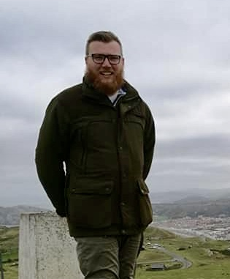 | Luke Aislabie  Luke joined Cefas as a fisheries scientist to work on a biological sampling programme in July 2017 following a degree in Aquaculture and fisheries management at the University of Greenwich. Luke subsequently joined the Salmon and Freshwater team to work on a variety of projects, including European eel habitat use and production, risk analysis of non-native species and the telemetry of Atlantic salmon.  RELEVANT EXPERIENCE  Risk analysis of non-native species  Luke has carried out non-native risk screening and full assessments of aquatic species, mainly freshwater and semi-diadromous fishes, for the European Commission and other overseas customers. Future risk assessment and pathway analysis work is anticipated for risk assessment areas in the Caribbean.  Habitat use and production of European eels  Luke participates actively in studies to produce scientific evidence to inform advice and for publication in peer-reviewed papers regarding habitat use of eels in various water bodies within England and Wales.  RELEVANT PUBLICATIONS  Aislabie, L.R., Copp, G.H., Verreycken, H. & Chapman, D. 2018. Study on Invasive Alien Species – Development of risk assessments to tackle priority species and enhance prevention. Contract No 07.0202/2016/740982/ETU/ENV.D2. Final Report, Annex 3: Risk Assessment for Morone americana (Gmelin, 1789). (In press)  Bašić, T., Aislabie, L, Ives, M., Walker, A (in preparation). Temporal and spatial utilisation of lacustrine habitats by the European eel (Anguilla anguilla) in the UK  Stebbing, P.D., Copp, G.H., Aislabie, L., Davison, P.I., et al. (in preparation). Risk screening of non-native aquatic species in the Arabian/Persian Gulf and the Gulf of Oman.  Vilizzi, L., Copp, G.H., Aislabie, L., et al. (in preparation). Assessing the risks posed by non-native aquatic species using the Aquatic Species Invasiveness Screening Kit (AS-ISK) – A global trial application to marine, brackish and freshwater taxa.
POSISTION

Fish biologist (freshwater and diadromous)

QUALIFICATIONS

BSc in Aquaculture and Fisheries Management

AREAS OF EXPERTISE

• Freshwater and diadromous fish biology and ecology
• Non-native species risk analysis and management
• Biological sampling
• Fish capture and monitoring
• Assessment of habitat by eels, cyprinids and salmonids

PUBLICATIONS

One peer-reviewed risk assessement report is in press and three manuscripts for peer-reviewed, international journals are currently in preparation.

